ADMIN (ORACLE) GUIDE

1. After clicking on the **View Reports** button admin will be redirected you to Oracle Login from where you can login with your username and password

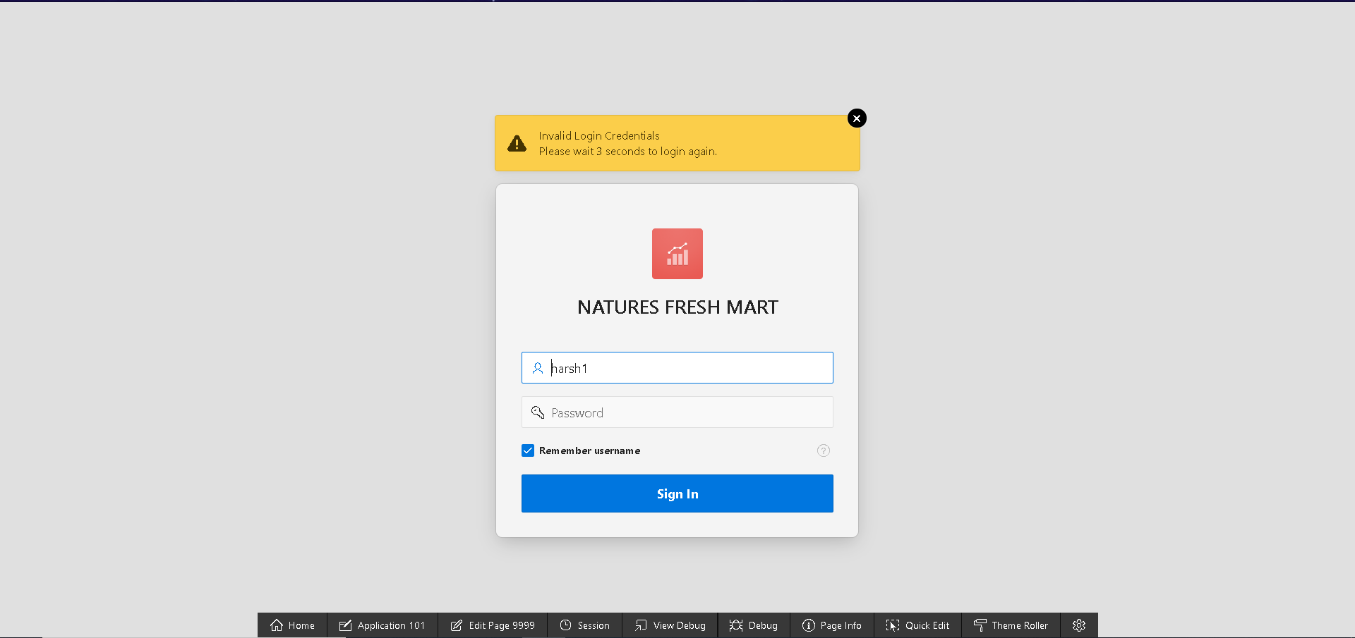

1. After logging in admin will be presented with dashboard where he can view the trader’s **master-details** of **shop and products** and **product and reviews**, information of highest **sold products, highest grossing products, monthly orders and pending order** in calendar

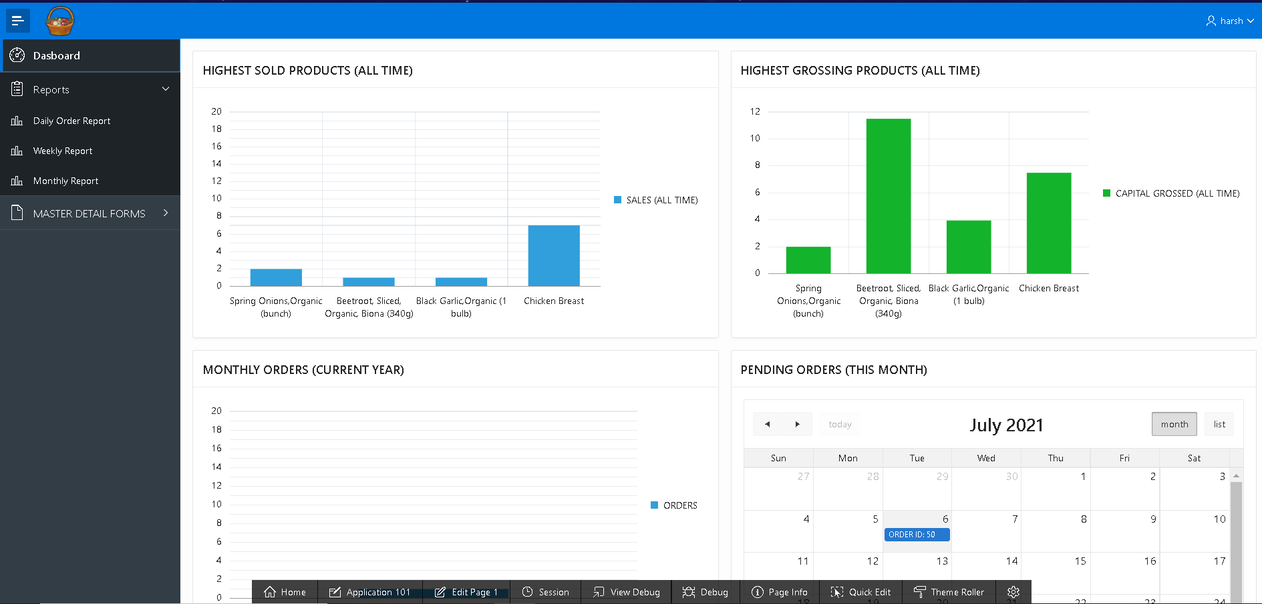

1. The **MASTER DETAIL FORM** section contains two master detail forms i.e. **SHOPS AND PRODUCTS AND PRODUCTS AND REVIEW**

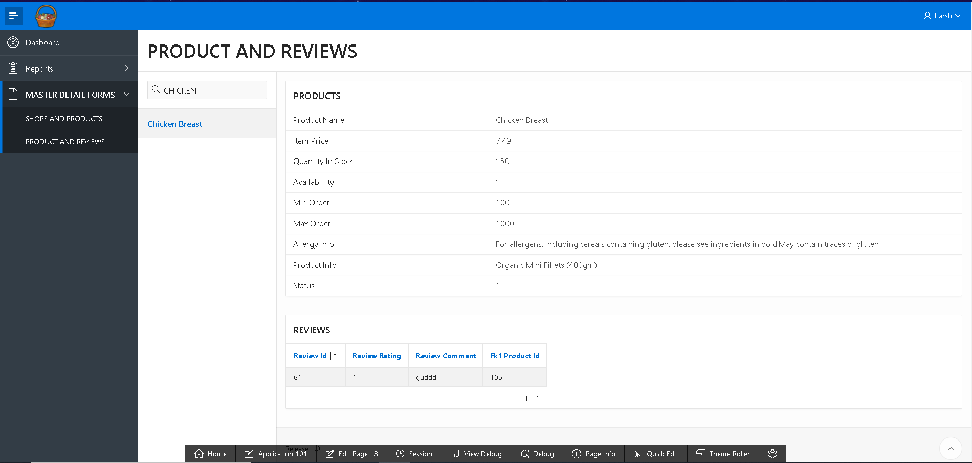

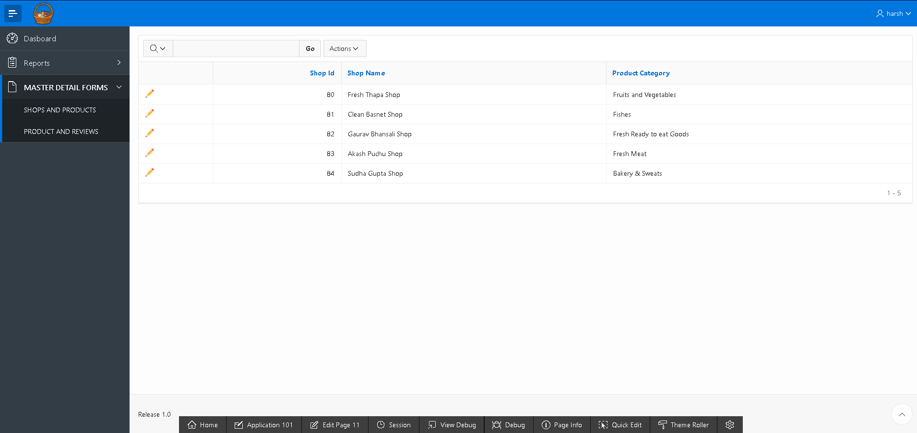

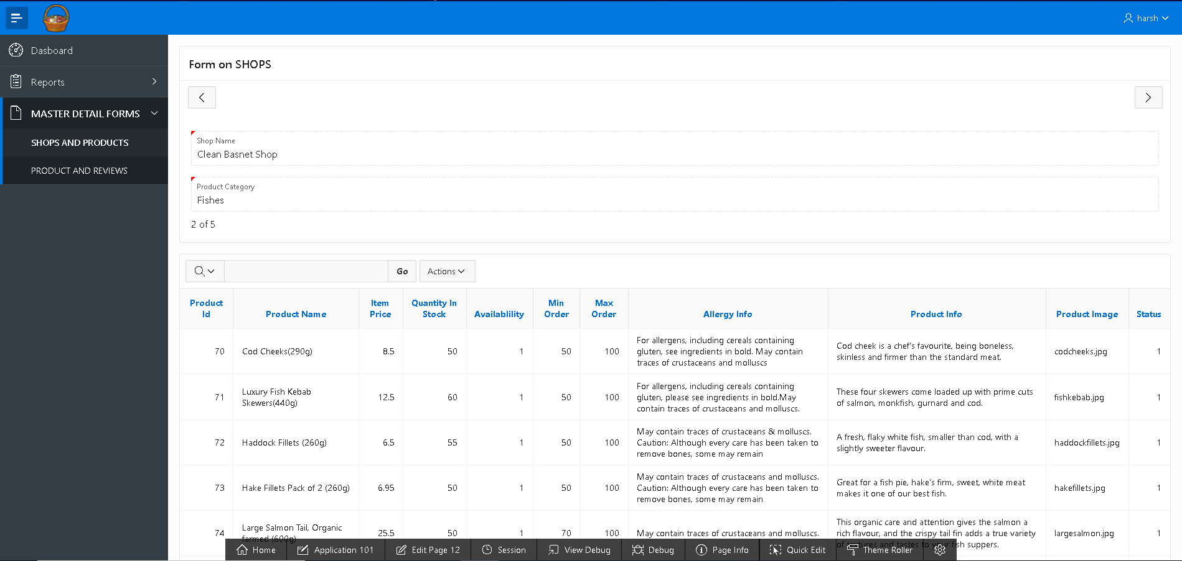

1. The Report section contains three reports **Daily Report, Weekly Report and Monthly Report** , the screen shots of which are provided below

**DAILY ORDER REPOR**

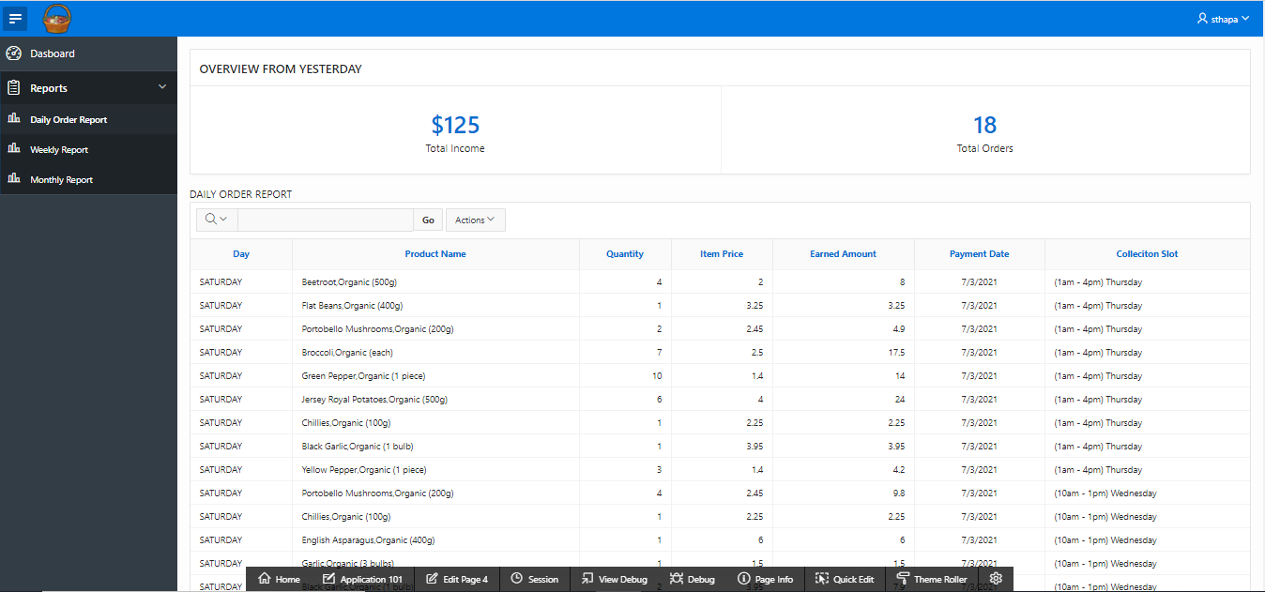

**WEEKLY REPORT** displays quantity, income of all the traders in past 7 days.

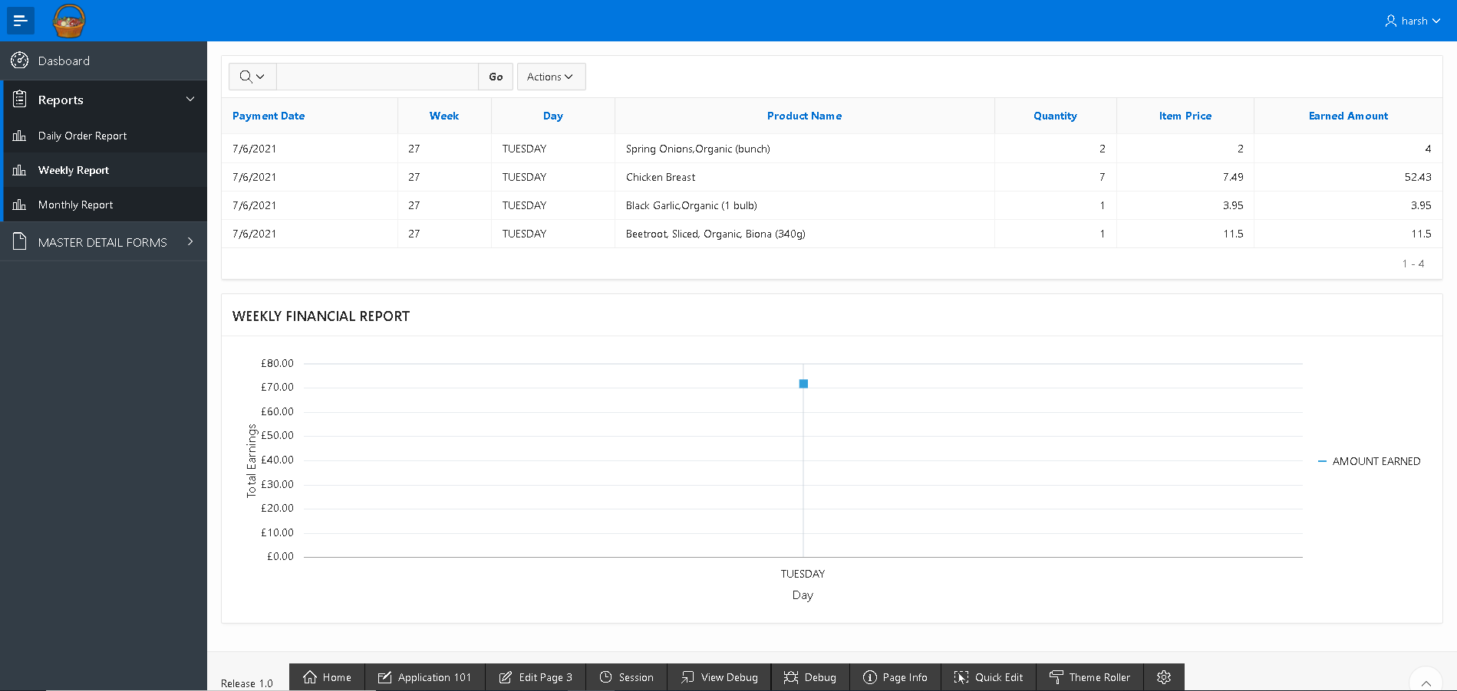

1. **MONTHLY SALES REPORT** displays quantity sold in past 30 days all the traders, earned amount and also a chart.

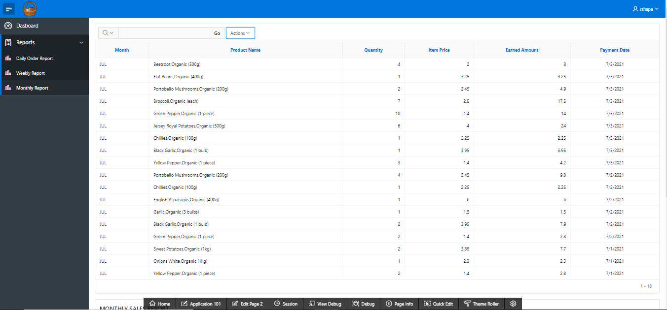

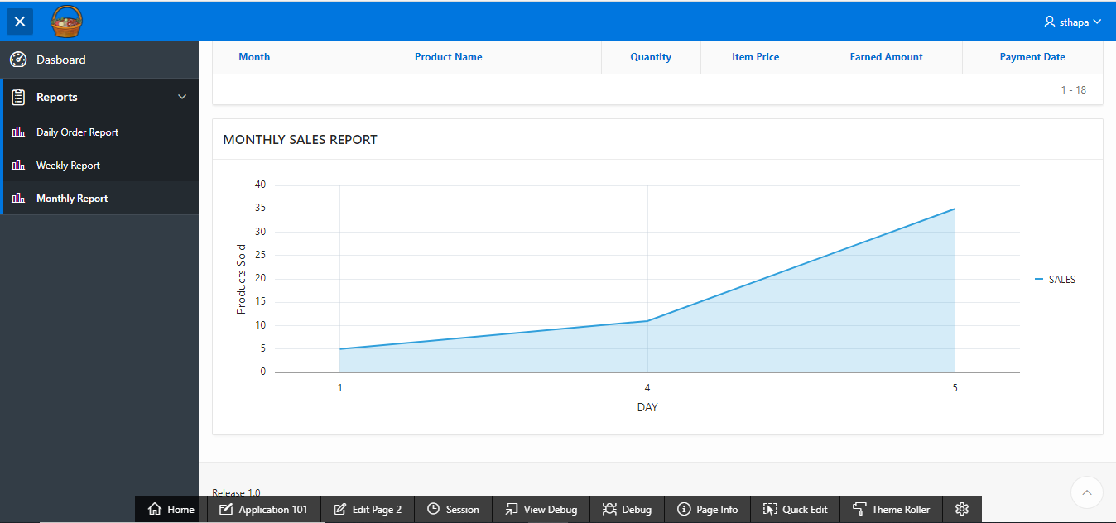

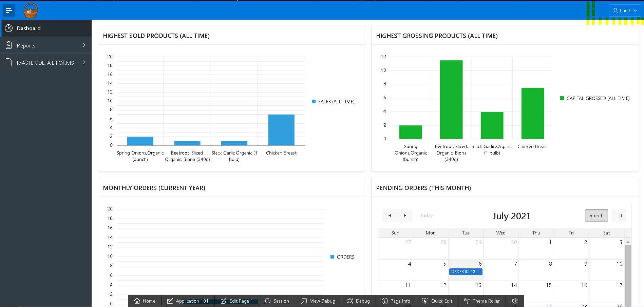

LOGOUT